**OUTPUT:**

**Database:**

CREATE TABLE books (isbn VARCHAR(20),title VARCHAR(100),author VARCHAR(100),price DECIMAL(8,2));

INSERT into books values('123','The India Story','Bimal Jalal',500),('102','Hamlet','William Shakespeare',350), ('125','Julius Caesar','William Shakespeare',400),('143','David Copperfield','Charles Dickens',250),('523','Oliver Twist','Charles Dickens',275),('901','Three Men in A Boat','Jerome K Jerome',374);

SELECT * from books;

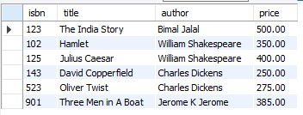

**GUI:**

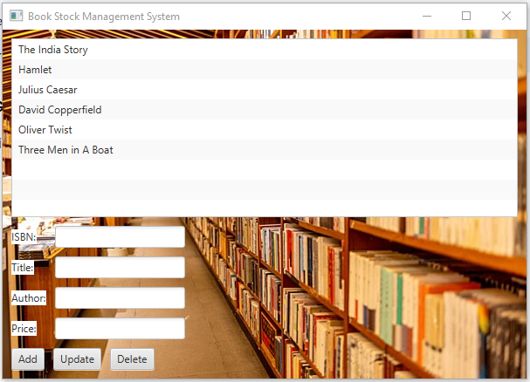

**GUI After Add/ Insert Operation:**

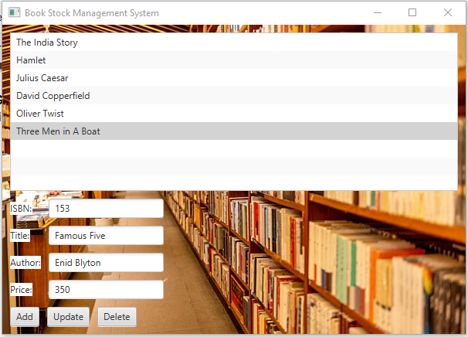

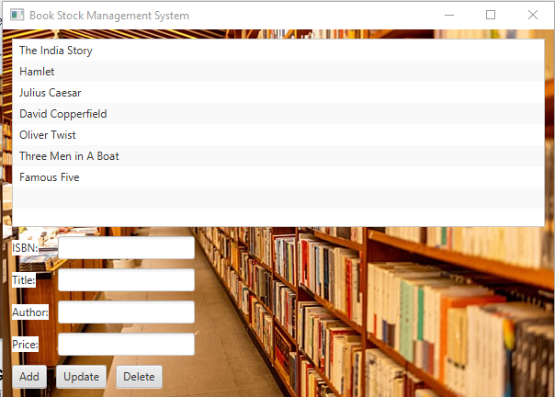

**Database after insert operation**

SELECT * from books;

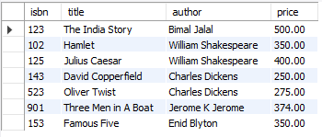

**GUI after update operation**

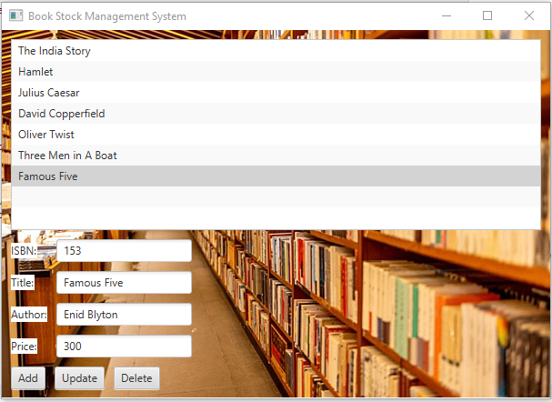

**Database after update operation:**

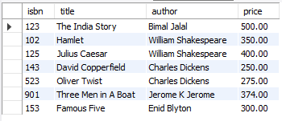

**GUI after Delete operation:**

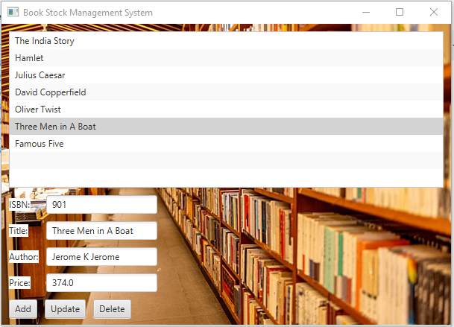

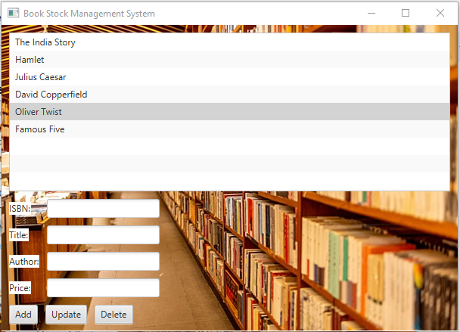

**Database after delete operation:**

